Syeda Reeha Quasar

14114802719

4C7

Aim

Write a program to find whether a number is prime or not.

Experiment - 1

Object Oriented Programming Lab

# **EXPERIMENT – 1**

## **Aim:**

Write a program to find whether a number is prime or not.

## **Source Code:**

#include <iostream>

#include <math.h>

using namespace std;

bool isPrime(int n){

    if (n < 2) return false;

    for (int i = 2; i < n; ++i) {

        if ((n % i) == 0) return false;

    }

    return true;

}

bool isPrime1(int n){

    if (n < 2) return false;

    if (n % 2 == 0) return false;

    for (int i = 2; i < sqrt(n); ++i) {

        if ((n % i) == 0) return false;

    }

    return true;

}

int main() {

    cout << "Enter the number you wan to check whether prime or not";

    int n;

    cin >> n;

    cout << "result = " << isPrime(n);

    cout << "result = " << isPrime1(n);

    return 0;

}

## **Output:**

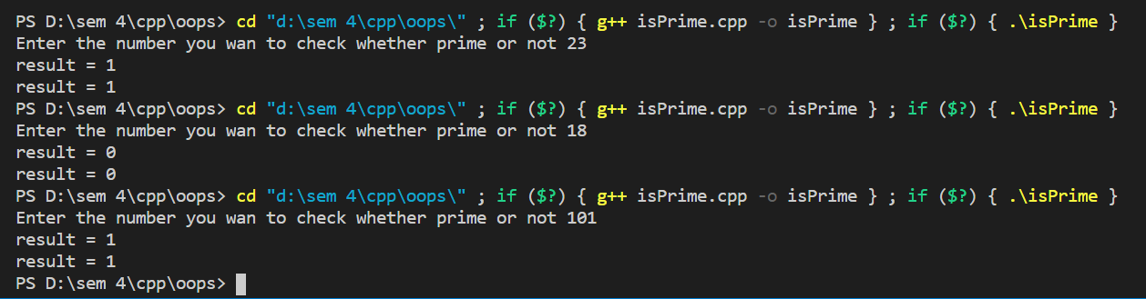

# **Viva Questions**

### **1. What are the different data types present in C++?**

Ans.

The 4 data types in C++ are given below:

* Primitive Datatype(basic datatype). Example- char, short, int, float, long, double, bool, etc.
* Derived datatype. Example- array, pointer, etc.
* Enumeration. Example- enum
* User-defined data types. Example- structure, class, etc.

### **2. What is the difference between C and C++?**

Ans.

The main difference between C and C++ are provided in the table below:

|  |  |
| --- | --- |
| C | C++ |
| C is a procedure-oriented programming language. | C++ is an object-oriented programming language. |
| C does not support data hiding. | Data is hidden by encapsulation to ensure that data structures and operators are used as intended. |
| C is a subset of C++ | C++ is a superset of C. |
| Function and operator overloading are not supported in C | Function and operator overloading is supported in C++ |
| Namespace features are not present in C | Namespace is used by C++, which avoids name collisions. |
| Functions can not be defined inside structures. | Functions can be defined inside structures. |
| calloc() and malloc() functions are used for memory allocation and free() function is used for memory deallocation. | new operator is used for memory allocation and deletes operator is used for memory deallocation. |

### **3. What are class and object in C++?**

Ans.

A class is a user-defined data type that has data members and member functions. Data members are the data variables and member functions are the functions that are used to perform operations on these variables.

An object is an instance of a class. Since a class is a user-defined data type so an object can also be called a variable of that data type.